A Study of Colors in Facial Make up for Character Definition in Beijing Opera

Xiaoshuang Zhang, Donghyuk Choi

Department of Visual Contents, Division of Digital Contents
Graduate School of Dongseo University, Dongseo University
Busan, South Korea
xiaoshuang0904@gmail.com, artistar@dongseo.ac.kr

Abstract

'Beijing opera' represents the essence of Chinese sentiments and expressiveness; thus it is an important element in understanding Chinese arts. This paper analyses the color in facial makeup, one of the key features of Beijing opera, in order to identify the features of characters. The scope of study addresses the facial makeup image of Beijing opera characters. As for methodology, a literature review was first conducted to study the concept of Beijing opera and its origin. An analysis of color association images then followed, addressing colors used in Beijing opera makeup. Thus it was shown that each character of Beijing opera, saeng (生), dan (旦), jeong (凈), chook (丑), has its own color scheme. This study is expected to inform coloring decisions in Beijing opera makeup, aiding the understanding of the artistic value of Beijing opera.

Keywords: Beijing opera, facial makeup, color

I. Introduction

Traditional Beijing opera is one of the traditional art formsof China [1]. It is a form of hyperbolic art; which is why makeup alsoexaggerated. Facial makeup in Beijing opera is free from the constraints ofordinary life; bold colors and transformation characterize diverse makeupdesigns. This makeup is not based on reality, but rather on the dramaticexpression of characters and personalities through colors. This study analyses thecolor of Beijing opera makeup, and offers a detailed analysis of colors infacial makeup from the perspective of Chinese traditional colors. The purposeof the study is to offer guideline for color decisions in Beijing opera makeup.To this end, the four images (生旦凈丑) whichrepresent four types of makeup in Beijing opera are studies to understand theconcept and origin of Beijing opera. For classification and detailed analysisof colors in Beijing opera makeup, the four categories of saeng (生 : Male role in traditional Chinese plays), dan(旦 : Female role in traditional Chinese plays), jeong (凈 : Supporting role in traditional Chinese plays), chook (丑 : Clown role in traditional Chinese plays) were used for coloranalysis of key characters. As a result, color characteristics of Beijing operamakeup are offered for different characters to offer an insight in to thecolors of Beijing opera makeup from the perspective of Chinese traditionalcolors.

II. Concept and Origin of Beijing Opera

'Beijing opera' is a comedic theatre where one actor or a number of actors cover their face and head with full make-up to play dramatic scenes. The expressive elements of Beijing opera consist of chang(唱:siniging), zhuo(做:movement), nien(念:lines), da(打:martial arts). Also the characters are categorised into saeng (生), dan (旦), jeong (凈), and chook (丑). Most works of 'Beijing opera' depict ancient Chinese tailes and scenes from ordinary life. Directorial variations and trends through the ages have established consistent standards of character categories based mainly on gender, age, personality, disposition and appearance. Beijing opera is a complex art which combines many elements of traditional arts; thus it merits an in-depth study into its origin, development and current trends.
It is thought that Beijing opera came into its original form around mid-18th century and was completed in its current form during the reign of Gagyung of Qing dynasty (1796-1820). However, Beijing Opera, a representative form of Qing provincial theatre, stems from the long tradition – from Japgeuk (雜劇) and Namhee (南戲)of Song dynasty to Japgeuk (雜劇) of Yuan dynasty and the comedies of Gongang (昆曲) during Ming dynasty [2]. In particular, the japgeuk of Song dynasty shows a completed form of comedic theatre where actors perform asides, soliloquy and songs.

III.Color analysis in Beijing Opera Makeup

Color carries an important symbolism in Beijing opera makeup, aiding the expression of dramatic themes and characters. Color combinations in makeup enhance the expression of sentiments in drama and add to the artistic appeal of opera. Hence a literature review has identified strings of research into the visual image, sense vocabulary, and adjective image of colors, as well as color association images and relationship between industries; there is also a tradition of research on sense vocabulary categories extracted from Beijing opera makeup. Color association images, including achromatic colors, are shown in <TABLE I> in the order of color wheel.

TABLE I
COLOR ASSOCIATE IMAGES

Color | Association Image
Red | Passionate, vigorous, vitality, intense, soft and delicate, hot, strong, courage, power
Orange | vigorous, passionate, dynamism, light, warm, energetic
Yellow | hope, eye-catching, vigorous, cute, weak, hero, bright, fun
Green | eco-friendly, relaxed, refreshing, comfortable
Aqua | cool, pure, uncorrupt, cheerful
Blue | credible, stable, loyal, masculine, cold, comfortable, quiet
Purple | luxurious, noble, attractive
Gray | stable, easy, ordinary
Black | urban, solid, heavy, simple
White | pure, noble, clear, comfortable

A. Seng（生）

Collection of colors from Beijing opera was conducted according to the categories of saeng (生), dan (旦), jeong (凈), and chook (丑) and from facial makeup images. Characters are organised from colors. [4].

TABLE II
SENGHWANG (生行) COLOR IMAGES AND COLORING SAMPLE

Character Image | Facial Makeup Image | Color/Brightness/Chroma | Keywords
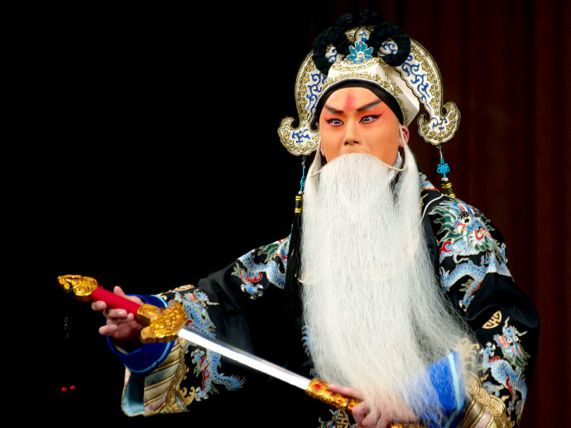  Old Man(老生) | RGB:244/157/104  RGB:226/92/55  RGB:252/108/100 | HSB:25/57/96  HSB:13/76/89  HSB:3/60/99 | Strong, Energetic
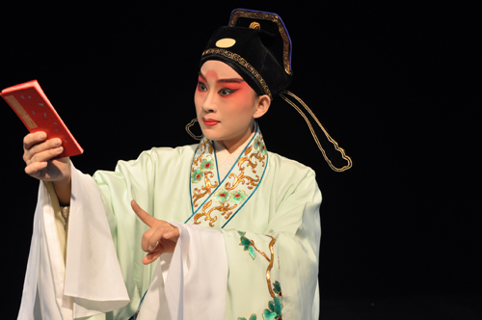Young Man (小生) | RGB:237/163/126  RGB:224/78/63  RGB:220/118/95 | HSB:20/47/93  HSB:6/72/88  HSB:11/57/86 | Vigor, Dynamic, Vitality
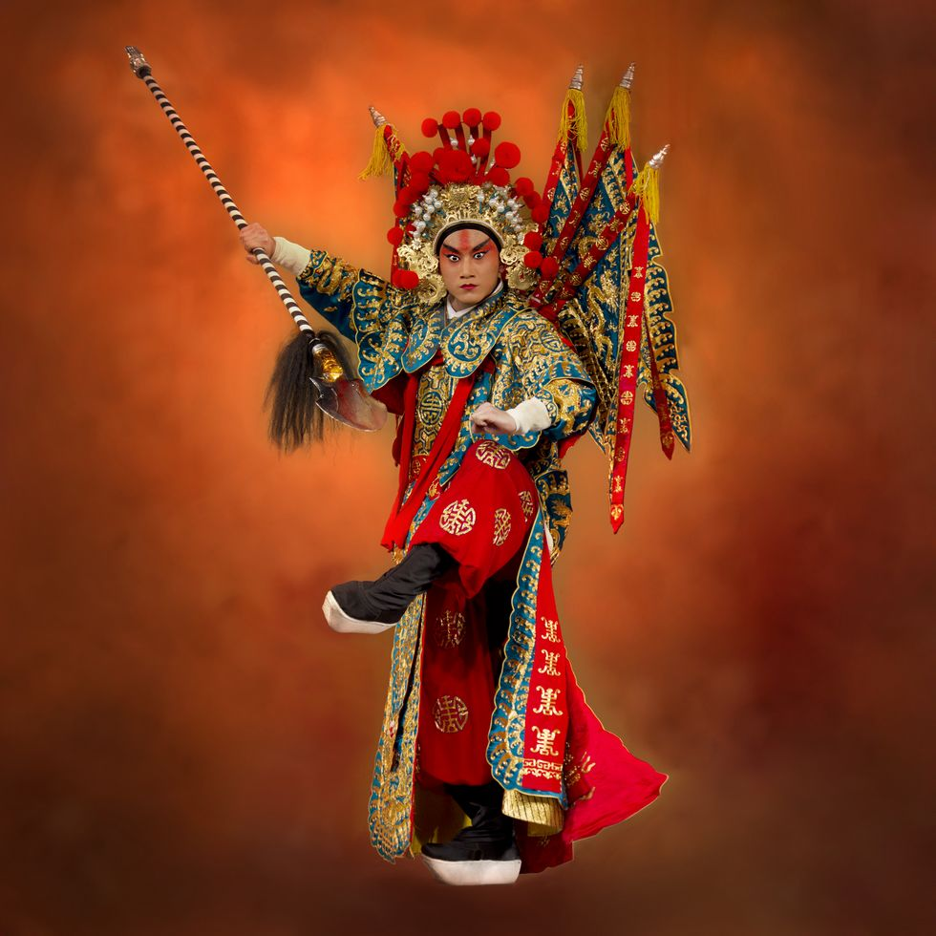  Warrior (武生) | RGB:194/130/92  RGB:159/37/14  RGB:187/65/54 | HSB:22/53/76  HSB:10/91/62  HSB:5/71/73 | Courage, Power, Intense
For color association image of saenghwang (生行), facial makeup color images are matched to character color association image and character personality symbols as in <TABLE I> Old man (老生) is manly characters beyond middle age (over 35). Key makeup colors are shown in RGB as in <TABLE II> Color symbolism includes strength, and energy. Young man (小生) refers to youth between 20 to 30 years og age. Key colors of makeup are also shown in <TABLE II>. Color symbols include vigor, dynamism and vitality. Warrior (武生) represents generals or military leaders. Key colors are shown in RGB in <TABLE II>. Color symbolism includes courage, power and intense.

B. Dan（旦）

TABLE III
DANHANG（旦行） COLOR IMAGES AND COLORING SAMPLE

Character Image | Facial Makeup Image | Color/Brightness/Chroma | Keywords
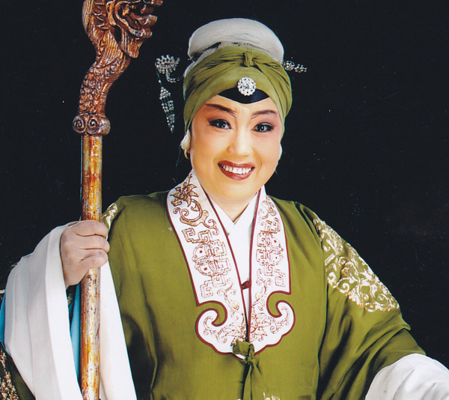  Old woman (老旦) | RGB:228/192/158  RGB:213/126/99  RGB:206/117/113 | HSB:29/31/89  HSB:14/54/84  HSB:3/45/81 | dominant, full of energy
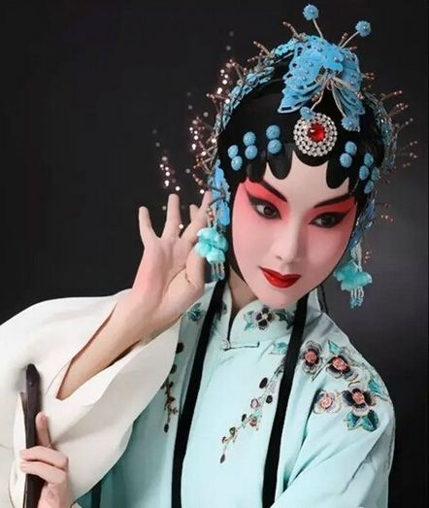  Young woman (正旦) | RGB:226/171/168  RGB:191/71/72  RGB:169/35/42 | HSB:3/26/89  HSB:359/63/75  HSB:357/79/66 | soft and delicate
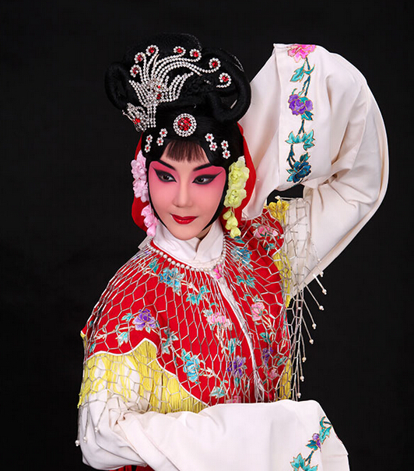  Girl (花旦) | RGB:241/151/151  RGB:201/62/85  RGB:161/14/33 | HSB:0/37/95  HSB:350/69/79  HSB:352/91/63 | lovely, cheerful
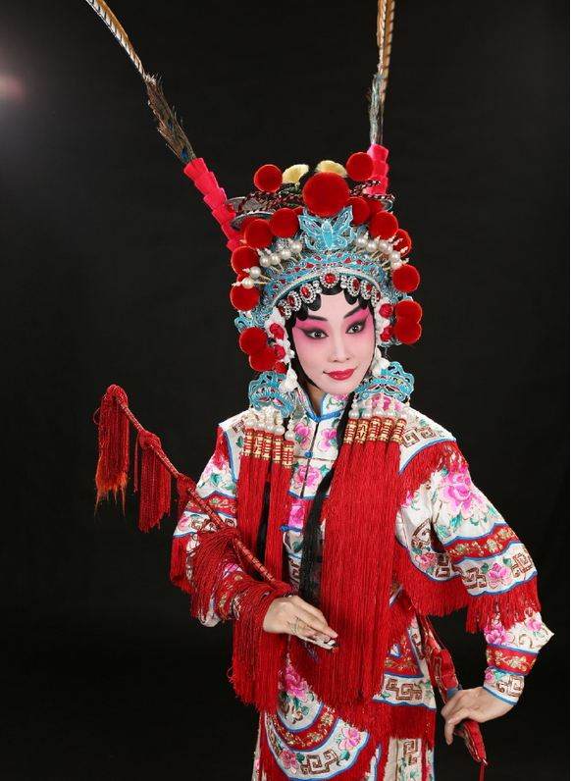  Warrioress (武旦) | RGB:234/183/179  RGB:227/99/134  RGB:222/63/91 | HSB:4/24/92  HSB:344/56/89  HSB:349/72/87 | passionate, cheerful
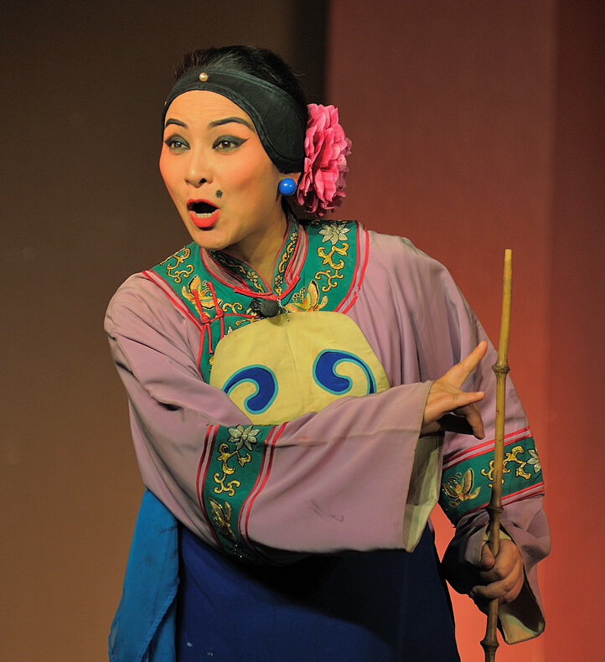  Scary old woman (彩旦) | RGB:242/165/95  RGB:240/141/86  RGB:247/77/52 | HSB:29/61/95  HSB:21/64/94  HSB:8/79/97 | lively, free

Old woman(老旦) (above 50 years of age) mainly use colors as shown in RGB in <TABLE III>. Color symbolism includes dominance, and energetic. Young woman (正旦) women of youth and middle age (30-50). Key colours for facial makeup are shown in <TABLE III>; symbolism includes soft and delicate. Girl (花旦) is normally from jeongdan. Key colors for facial makeup are shown in <TABLE III>, with symbolism of loveliness and cheerfulness. Warrioress (武旦) represents female masters of martial arts. With such key colors in <TABLE III>, color symbolism includes passionate and energetic. Finally, scary old woman (醜旦) uses key colors as shown in <TABLE III>. Color symbolism includes liveliness and freedom.

C. Jeonghang (凈行)

TABLE IV
JEONGHANG (凈行) COLOR IMAGES AND COLORING SAMPLE

Character Image | Facial Makeup Image | Color/Brightness/Chroma | Keywords
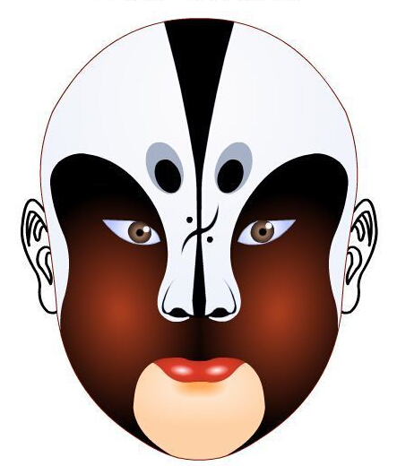  Jeongjeong (正凈) | 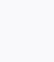RGB:249/249/21  RGB:158/58/26  RGB:13/3/2 | HSB:60/92/98  HSB:15/84/62  HSB:5/85/5 | strength, hero
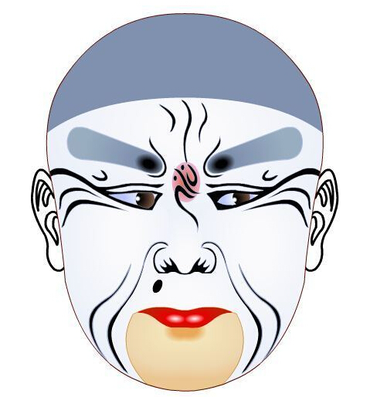  Bujeong (副凈) | 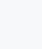RGB:247/248/250  RGB:152/173/192  RGB:128/145/175 | HSB:220/1/98  HSB:208/21/75  HSB:218/27/69 | cold
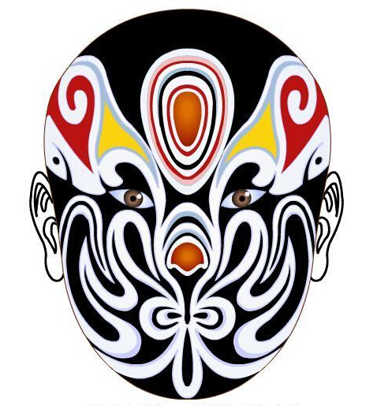  Wujeong(武凈) | 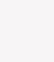RGB:247/245/246  RGB:250/210/14  RGB:208/93/4  RGB:187/19/19  RGB:0/0/0 | HSB:330/1/97  HSB:50/94/98  HSB:61/93/82  HSB:0/90/73  HSB:0/0/0 | courage,  hero, hope

Jeongjeong (正凈) is often a virile man. With key colours in RGB in <TABLE IV>, color symbolism includes strength and hero. Bujeong (副凈)represents villains or jokers. Key colors for character makeup are shown in RGB in <TABLE IV>; color symbolism includes coldness. Wujeong (武凈) indicates men who practice martial arts. Key colors of facial makeup are shown in <TABLE IV> in RGB. Colour symbolism includes courage, hero and hope.

D. Chookhang（丑行）

TABLE V
CHOOKHANG (丑行) COLOR IMAGES AND COLORING SAMPLE

Character Image | Facial Makeup Image | Color/Brightness/Chroma | Keywords
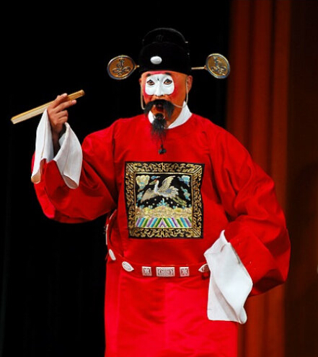  Moonchook (文丑) | RGB:191/43/17  RGB:244/253/250 | HSB:9/91/75  HSB:160/4/99 | intense, comfortable
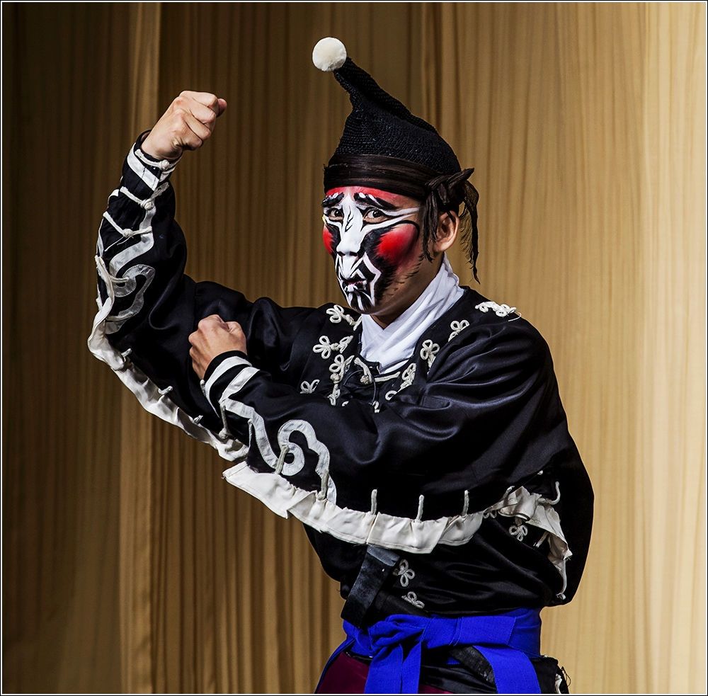  Muchook (武丑) | RGB:196/1/7  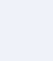RGB:242/243/248  RGB:44/42/47 | HSB:358/99/77  HSB:230/2/97  HSB:246/11/18 | simple,  intense

Munchook(文丑) tends to the comedic character in Beijing Opera. With key colors indicated in <TABLE V> in RGB, color symbolism includes intense and comfortable. Muchook (武丑) is often a funny character which practices martial arts. Key colors of facial makeup are shown in <TABLE V> in RGB. Color symbolism shows siple and intense.
Thus facial makeup colors saeng (生), dan (旦), jeong (凈), and chook (丑) mainly consist of red and achromatic colors of white and black; yellow is seldom used. Also, for each category, with red being a common element, saenghang and danhang have lower chroma compared to jeonghang and chookhang.

IV. Conclusion

This study analyses the colors of facial makeup in Beijing opera, a traditional Chinese theatre, as they represent various characters. The result of the analysis shows that, along with costume, facial makeup is used to represent the personality of characters. Even if the same color is used, high chroma can be used to represent intensive images whereas high brightness is used for soft images. This analysis allows us to propose a way of using facial makeup colors in setting characters in Beijing Opera. It also bears significance that color analysis methods informs the study of characters in Beijing opera. The study of colors in Beijing opera facial makeup will be an importance source in understanding Beijing opera around characters. More detailed analysis and research into the facial makeup in Beijing opera will facilitate the development of various contents using China’s traditional aesthetics.

References

[1] Kao,Shin, Jeonghwa Ha, Understanding Peking Opera, Korean Aesthetics Association, 2003.12, pp.329-359
[2] Kim,Hyung-Lan, A study on likeness and unlikeness of the performance literature in East Asia, The Society For Chinese Humanities In Korea, 2011.12, pp.299-317
[3] Xiao,Haili, Choi,Donghyuk, Analysis on Colors of Chinese Traditional Clothes Expressed in Animation, Korean Society Of Color Studies, 2016.8, pp.39-46
[4] Kim,Jiyong, Characteristics of Colors of Korean Traditional Mask, Korean Society Of Color Studies, 2016.8, pp.75-85

